15BCE0517

M.S.SANJAY

EXPERIMENT 4

1.

Block Transfer of data

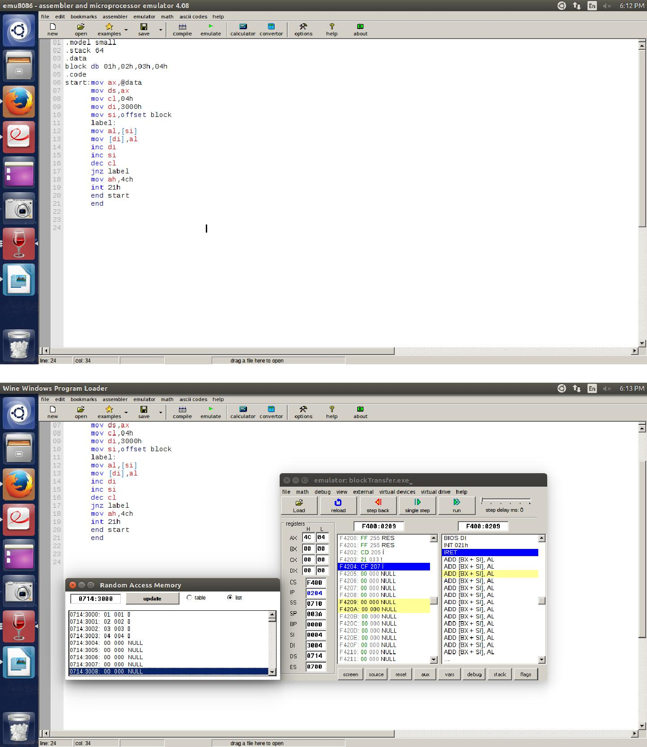

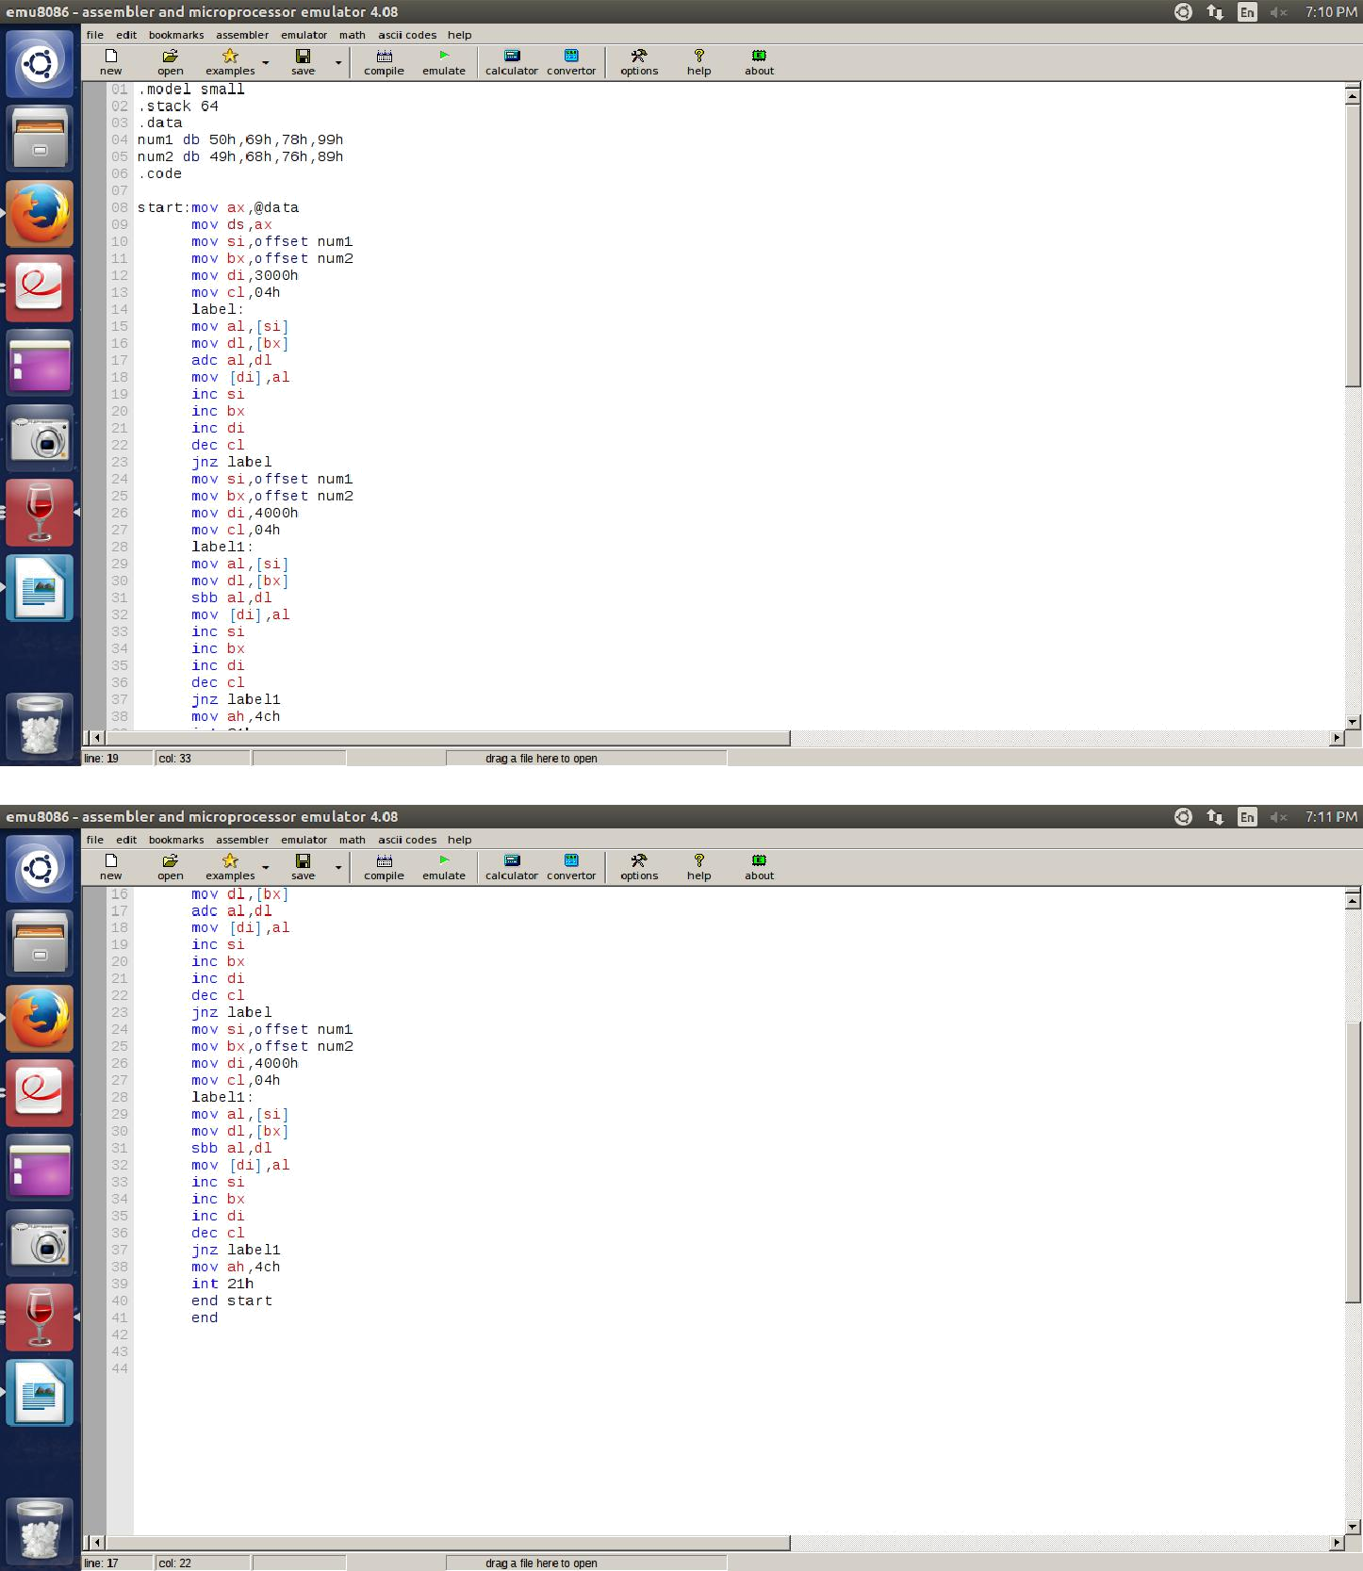2.Multi byte addition and subtraction

Addition

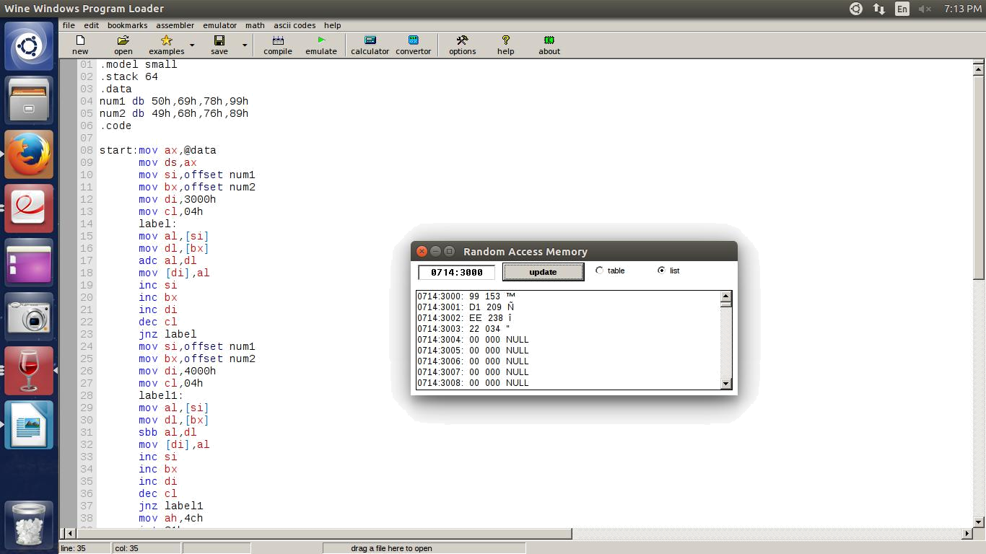

Subtraction

